**REPORT ON EDUCATIONAL VISIT TO AT SATISH DHAWAN SPACE CENTER SRIHARIKOTA (ISRO) on 22.01.2020**

**EVENT**: Educational visit

**Total students**: 44

**EVENT DESCRIPTION**: A visit had been organized by Lightworkers Academy to SDSC SHAR for the students of class IX, X,XI on January 22, 2020 . The Main objective of the visit was to provide a technical Exposure to the students about Space Technology. Totally 44 students of LWA visited the facility

**SESSION ACTIVITIES:** The students were accompanied by 4 faculty members .The buses with students have started from our school at 6:00 am and reached the ISRO campus at 10:00 am.

**ISRO VISIT**: Students visited ISRO and learnt about

• LCC (Launching Control Centre)

• MCC (Machine Control Centre)

• SLP(Second Launch Pad )

• FLP(First Launch Pad)

We visited the space museum in the same campus. The visit came to an end at 2:30pm.It was informative, interesting and successful visit.

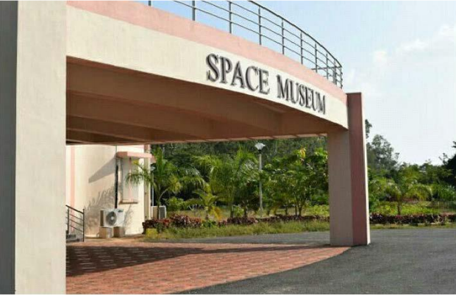

SATISH DHAWAN SPACE CENTRE(SDSC) or SRIHARIKOTA HIGH ALTITUDE RANGE(SHAR) is a rocket launch centre operated by Indian Space Research Organization (ISRO), located in Sriharikota in Andhra Pradesh. The Sriharikota range has been chosen for its proximity to the equator and to use the rotation of the earth .It is close to lake PULIKAT and it is about 100km north of Chennai and close to the Bay of Bengal. We learned about the computer system used in LCC for launch control. In **MCC(machine control centre)** is the focal point controlling vehicle. There are 8 hold buttons at different places around the range in case of abnormalities in sub-systems, the hold button is used to terminate the countdown . In case the abnormality has been resolved the first row is used to supervise to control the operations on the vehicle .Various chiefs of operations are seated in these rows is computers are connected by Ethernet and fiber optics.

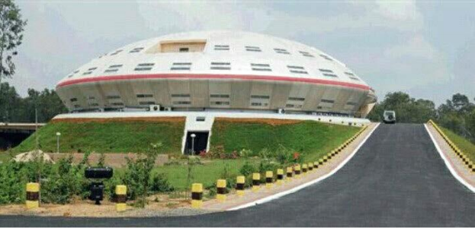 **FIRST LAUNCH PAD ( FLP)** is the polar satellite launch vehicle (PSLV).It is one of the 2 orbit launch pads at the site the other been the second launch pad . Unlike the UMBILICAL type this is a PEDESTAL type the whole tower moves away from the rocket just before the blast off, **SECOND LAUCH PAD ( SLP )** is the geosynchronous satellite launch vehicle (GSLV) .This is the location that we seen every time a launch is broadcast on television .The rocket is assembled and brought to the launch pad. The rocket is electrically insulated from lighting by four lightening protection towers. These towers also house high resolution cameras at several levels to monitor the various stages of the rocket. The launch pad itself is about 70 meters high .An anchor is present to hold the rocket in place until the time of blast off. **ISTRAC( ISRO TELEMETRY TRACKING AND COMMAND NETWORK )** is about the ground stations which are located at Bangalore ,Lucknow, Maurituis ,Sriharikota ,Portblair ,Thiruvananthapuram and the deep space network stations.

